|  |  |  |  |  |  |
| --- | --- | --- | --- | --- | --- |
| Date | 13-Dec-22 | | | Tester Name | Mayuri Patel |
| Environment | Penfax - Test | | | Login used |  |
| Operating System | Select OS | Version: | Update: | | |
| Software Used | Select Software | Version: | Update: | | |
| Select Software | Version: | Update: | | |
| Release version | 22.4.1 | | | | |
| Title |  | | | | |
| Test Type | Regression | | | | |
| Test Scenario | Process PEBA Daily/Scheduled Ad-hoc Payments Batch | | | | |
|  |  | | | | |
| Expected Results |  | | | | |
| Pass/Fail | Pass | | | JIRA# | N/A |

Describe your steps with screenshots:

Search in payment Production batch for PEPP Ad-hoc payments batch

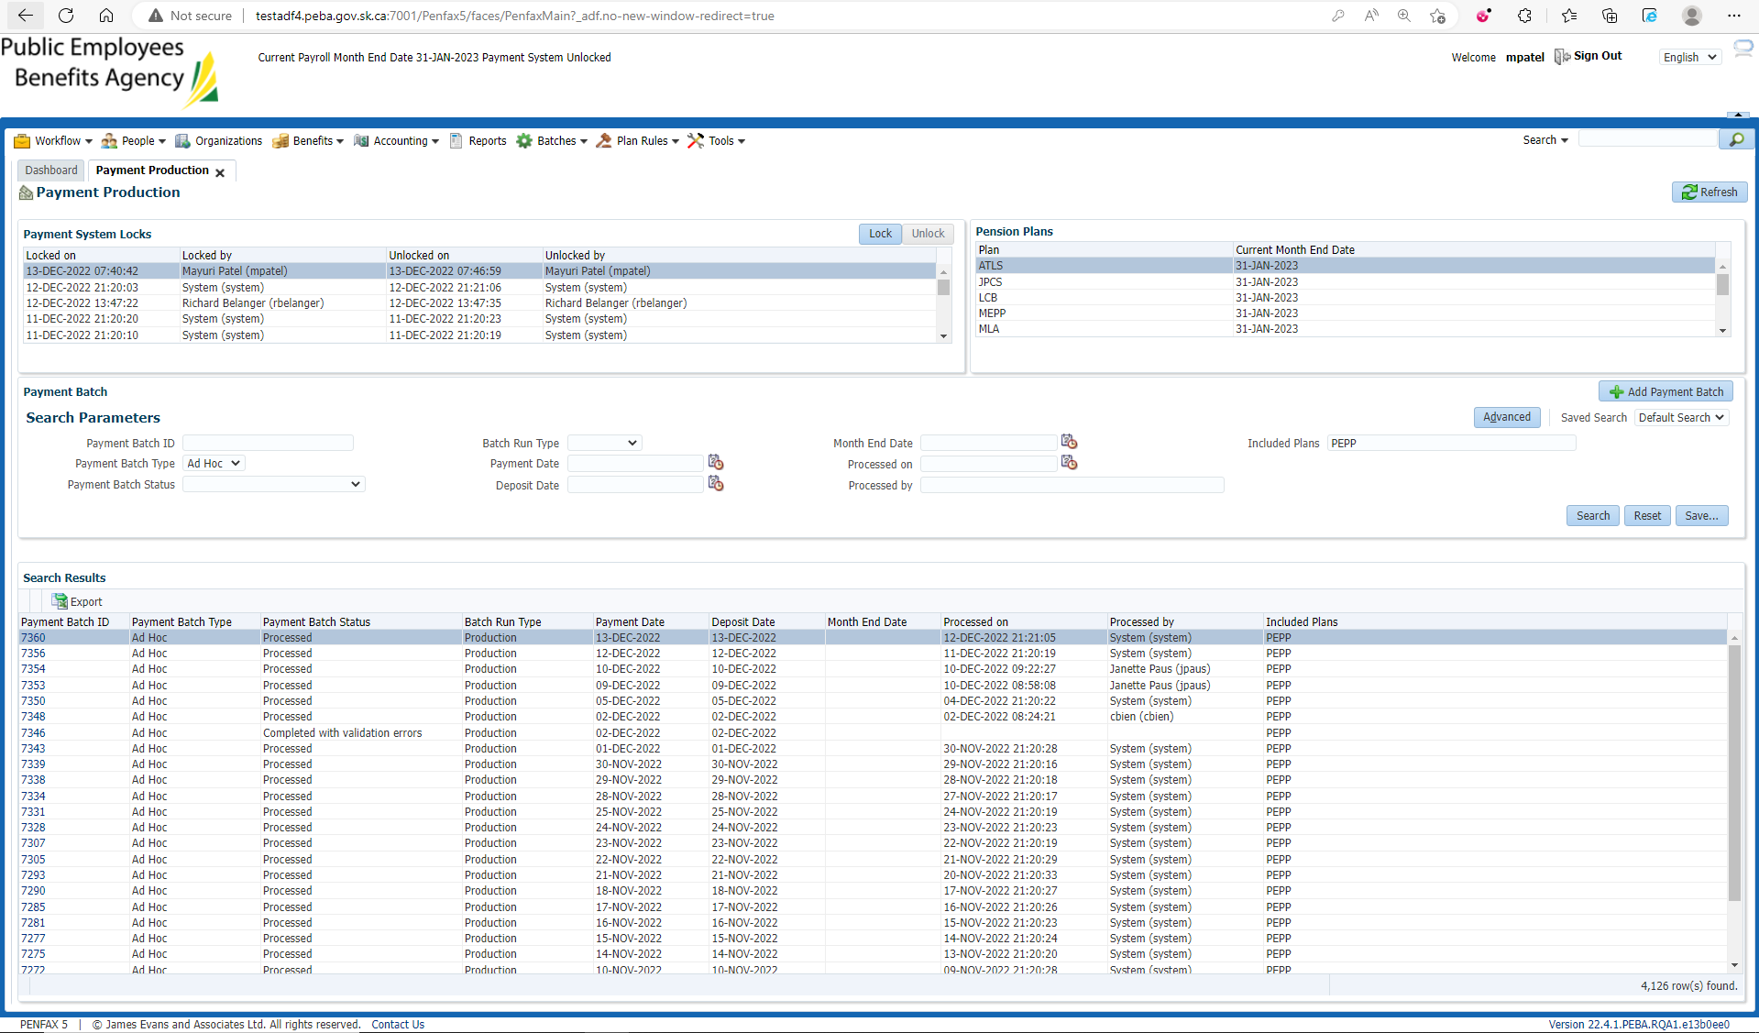

Lists all batches ran (with and without errors)

Select any batch ID and note down amount and stakeholder ID for that payment

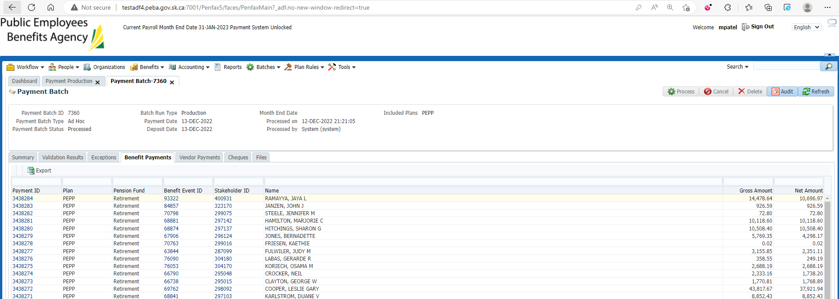

Verify by opening that stakeholder ID and making sure of the benefit is paid under Benefit Recipients 🡪 Ontime Amount

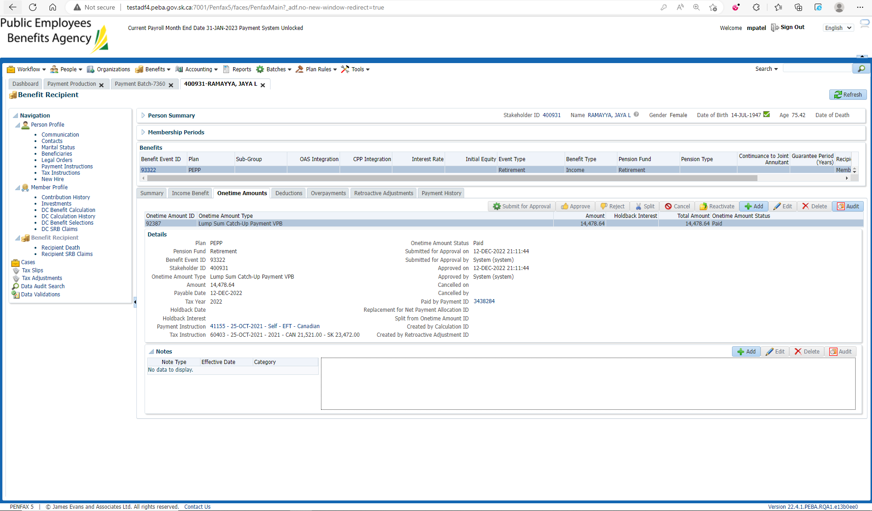

Likewise select another batch ID and note down amount and stakeholder ID for that payment

Verify by opening that stakeholder ID and making sure of the benefit is paid under Benefit Recipients 🡪 Ontime Amount

